Parameter checker user guide:
- Convert parameters specification file to excel “.xls” format. Sheet name must be ‘ParameterKeys’. Save it in the local drive.
- Export parameters excel file from T3000 by specifying the prefix for parameter key identification (e.g., “COMOS*”). Application can be used without specifying any prefix as well.
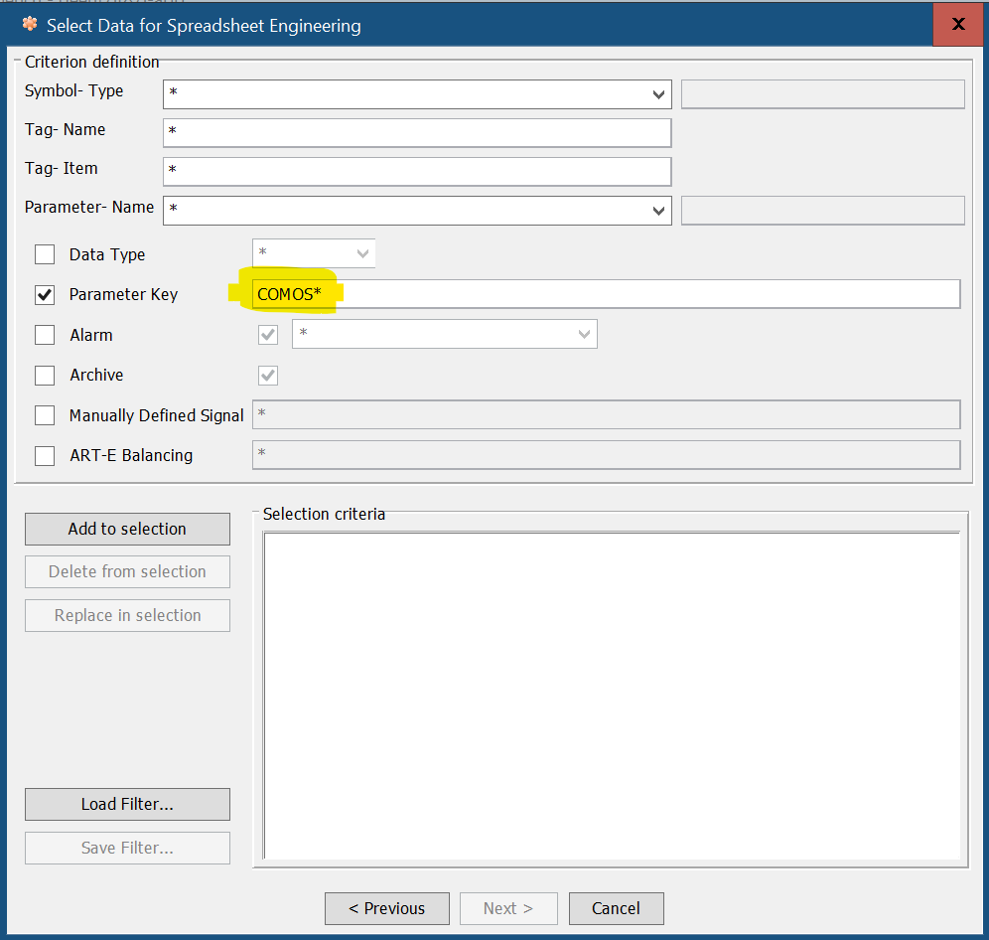

- Use “main.exe” to open the application. Alternatively, “main.py” can be used if python is installed and all python dependencies (modules) are installed in the computer.
- Following window will open with first three entry fields populated by their default values. Rest of the entry fields will be populated after browsing the required files. Application can be used without specifying any prefix as well.
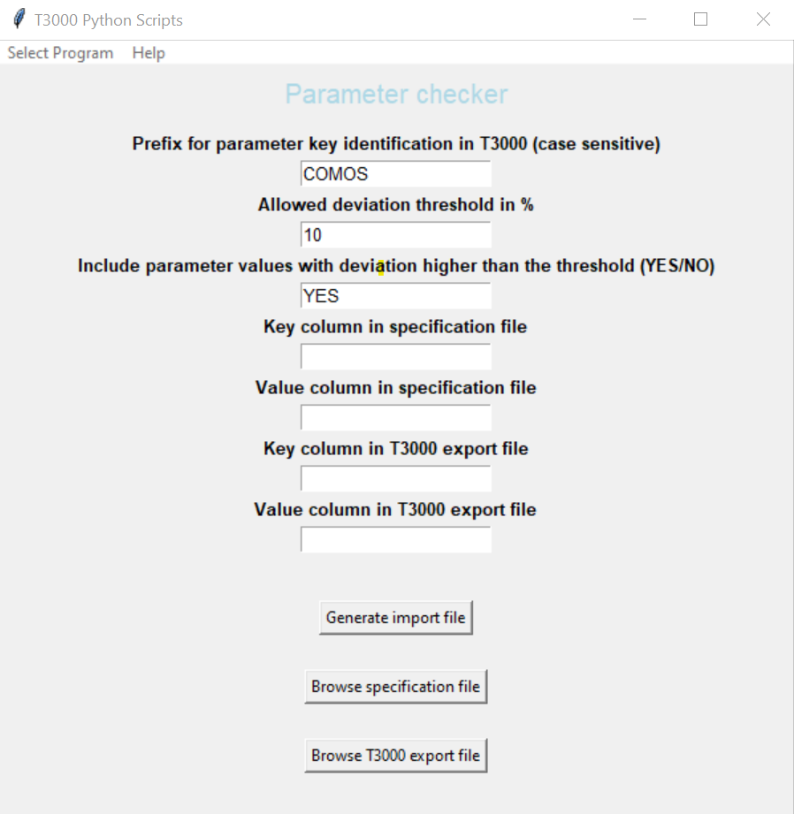
- Browse and select the specification file. (“.xls” file saved during S/N-1 of this document)
- Browse and select the T3000 export file. (“.xls” file saved during S/N-2 of this document)
- Check that the entry fields are correctly filled and modify if needed.
- Press the button “Generate import file”.
- If the program runs successfully, the folder “result” will open automatically. Four files will be generated. Analyze the results before import in T3000.
    - “T3000_param_import.xls” – This file will be used to update T3000 parameters.
    - “matched_param.csv” – This is the list of parameter keys which match between the specification and the T3000.
    - “unmatched_param_T3000.csv” – This file lists the parameter keys present in T3000 but not in specification file.
    - “unmatched_param_spec.csv” – This file lists the parameter keys present in specification file but not in T3000.

Additional information:
Before the application does any lookup between T3000 parameter keys and specification parameter keys, it formats key names and corresponding values.

The T3000 key names are formatted in following manner (order is important):
# Remove all single quote chars.
# Remove all double quote chars.
# Remove all space chars.
# Remove all tab chars.
# Remove the prefix for parameter key identification.
# Remove the colon char used after the prefix.
# Remove everything after the comma char, including the comma itself.

The specification key names and values are formatted in following order:
# Remove all single quote chars from the key name
# Remove all double quote chars from the key name
# Remove all space chars from the key name
# Remove all tab chars from the key name

